

**中原大學 雲端計算平台實務**

**11/19-作業報告**

**Administer containers in Azure**

**資訊四乙 10727211 林彥輝**

**授課教師：鍾武君 教授**

**中華民國一一○年十一月**

# Model Intro

**Administer containers in Azure**

**https://docs.microsoft.com/en-us/learn/paths/administer-containers-in-azure/**

# Summary Homework Assignment

## Model 2:Build a containerized web application with Docker

1. Set up Environment (Using Azure VM)

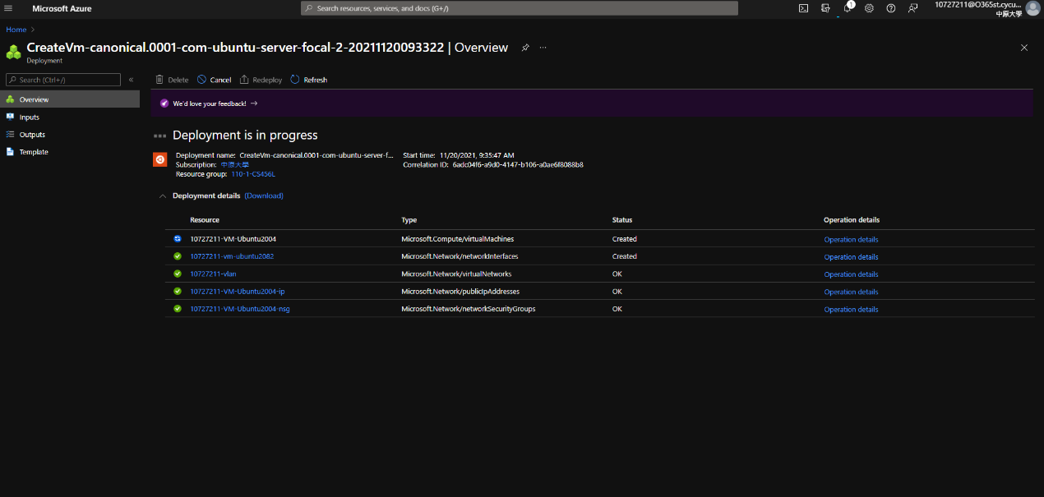

1. Install Docker and check Status

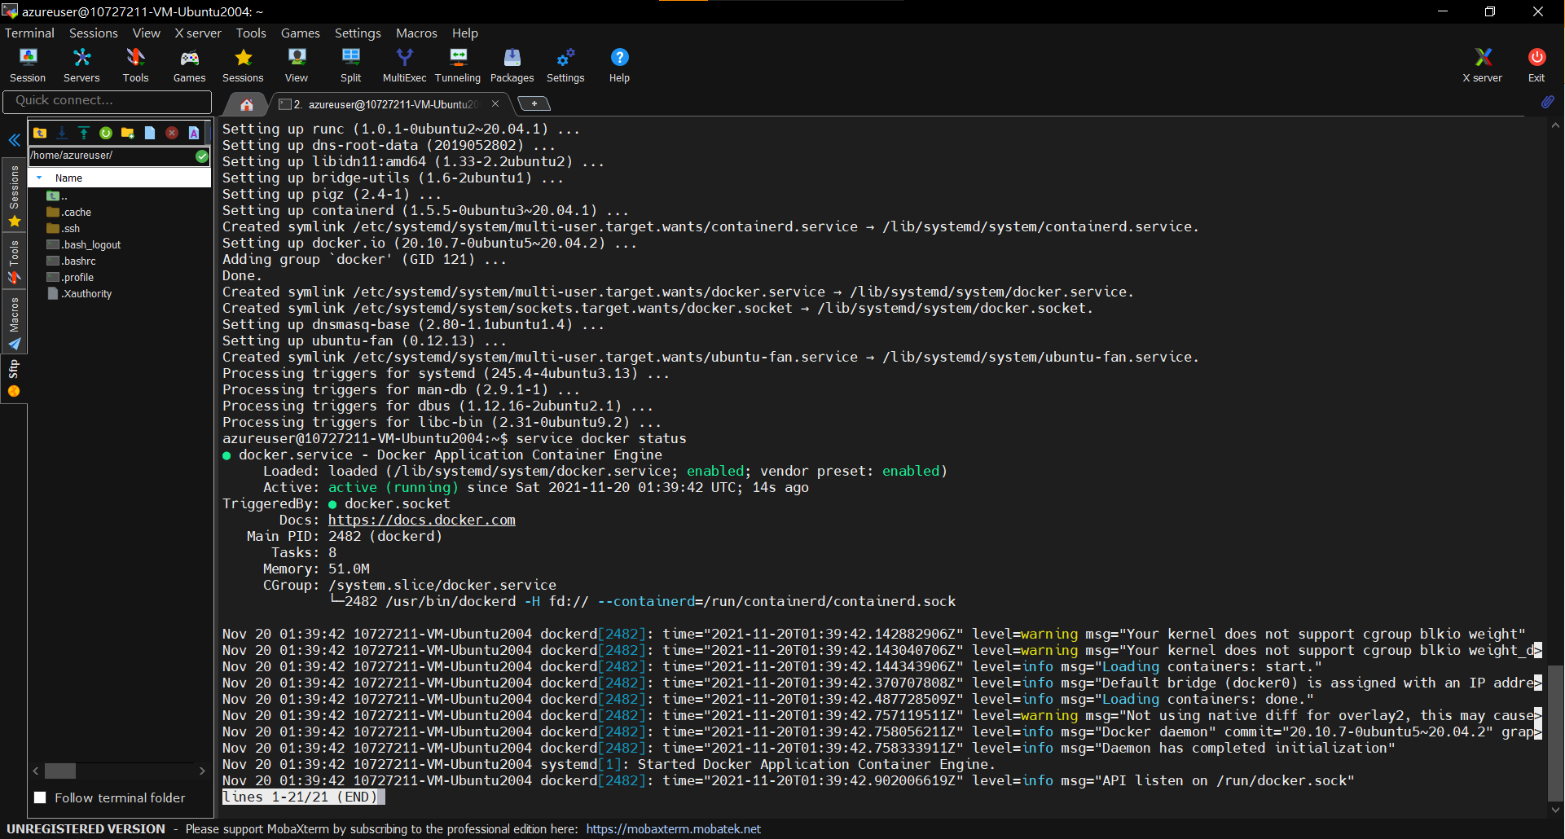

1. After docker run app, setting NSG port-forward (8080 port)

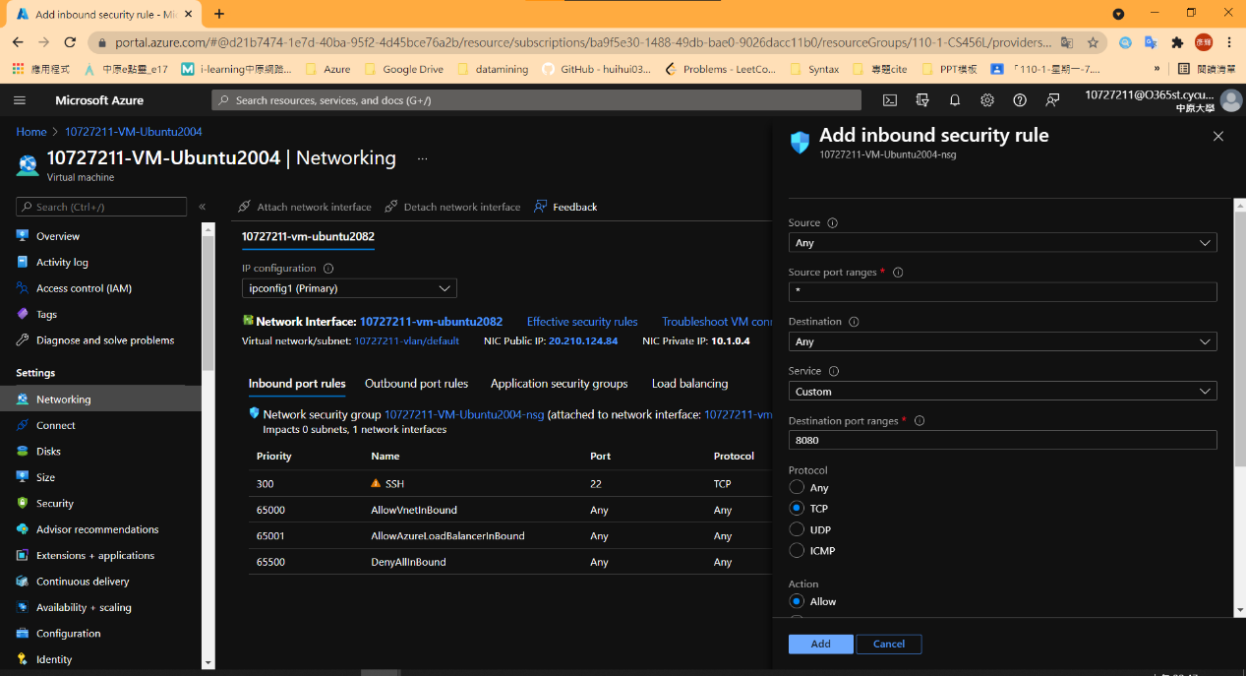

1. open url in browser : <VM_ip>:8080

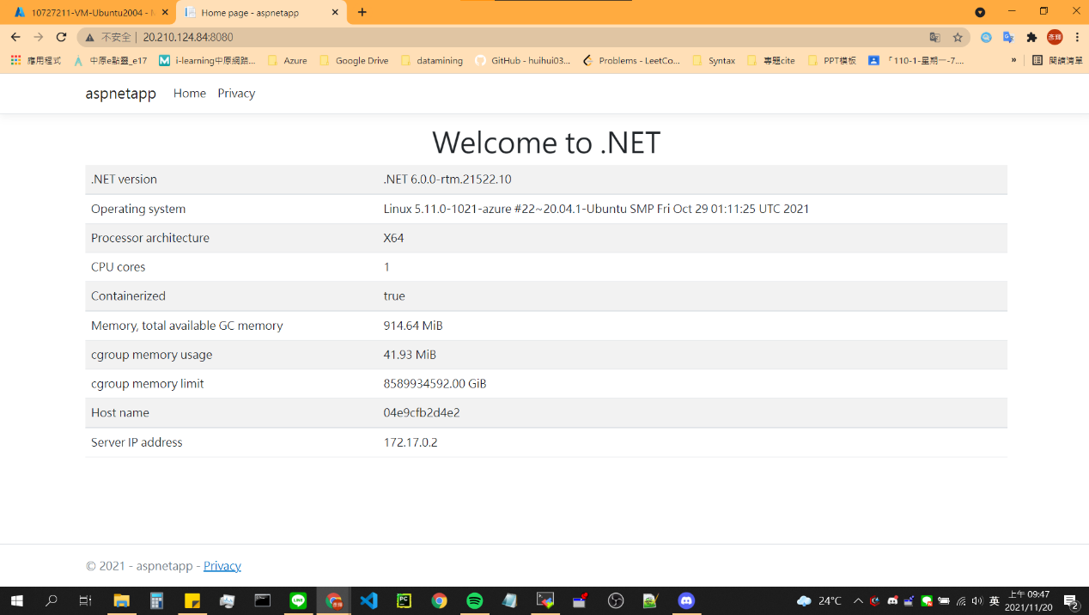

1. Create Container Registry

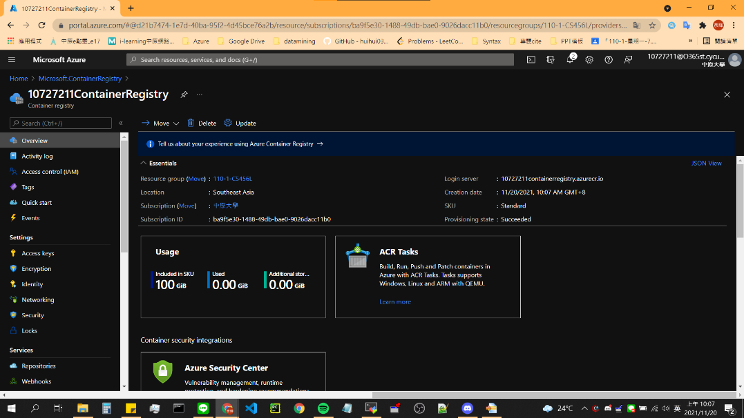

1. Push Image (cmd)

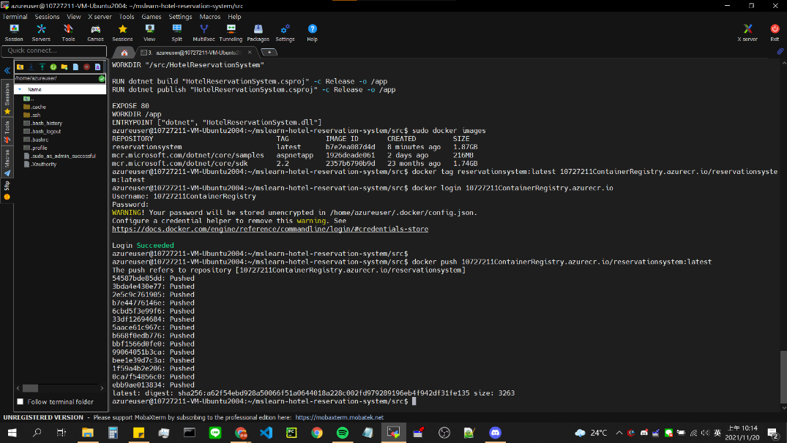

1. Push Image (Web)

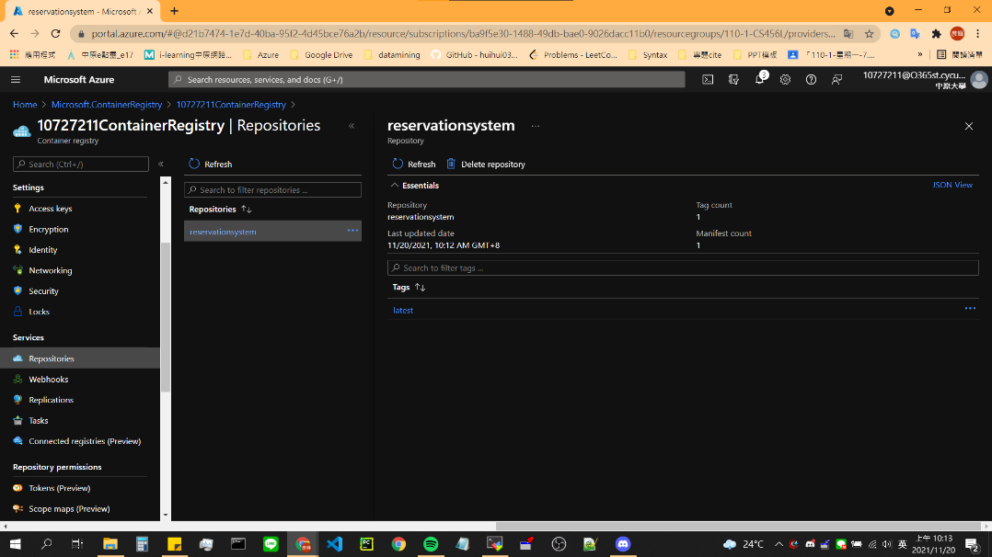

1. Create Container Instance

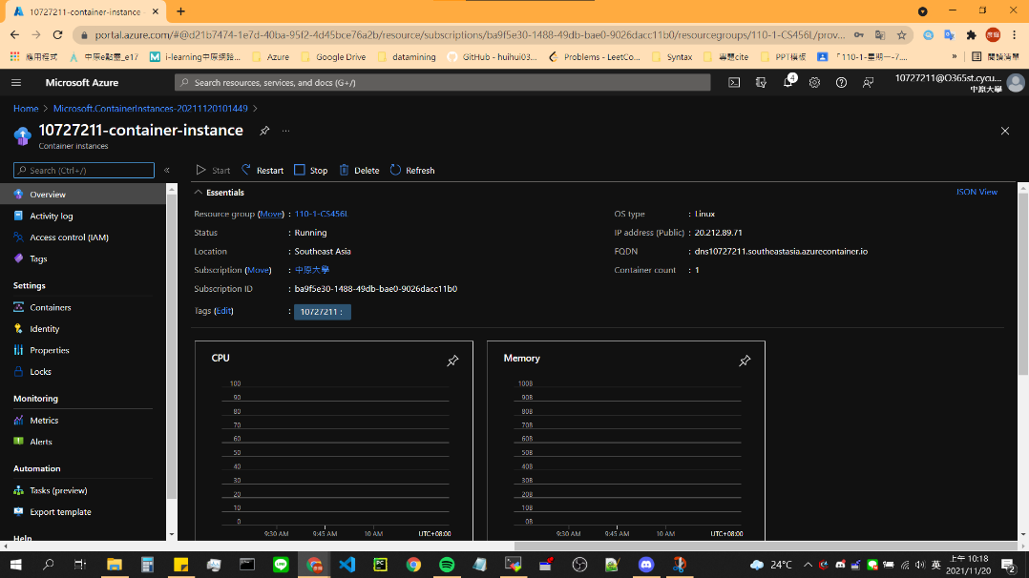

1. Result1 (using FQDN navigate)

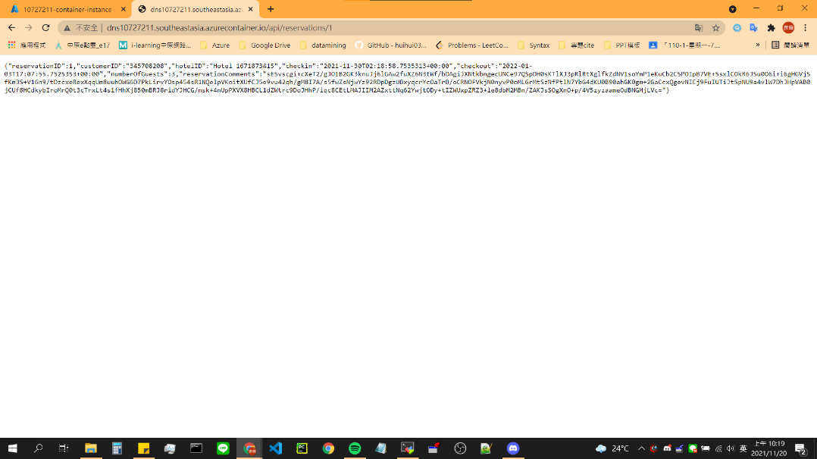

1. Result2 (using IP navigate)

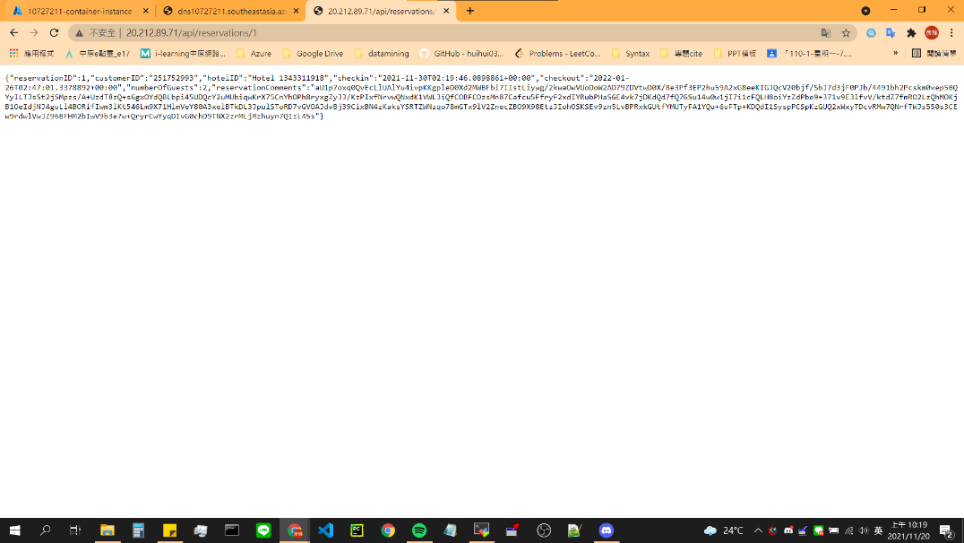

## Model 3:Build and store container images with Azure Container Registry

1. Create Azure Container Registry (using Azure Cloud Shell)

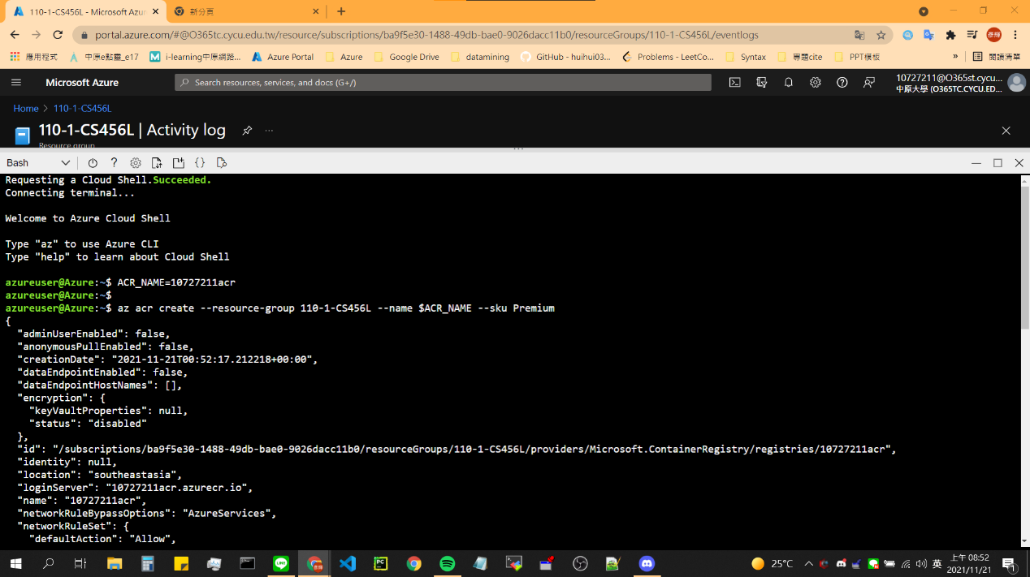

1. Write Dockerfile

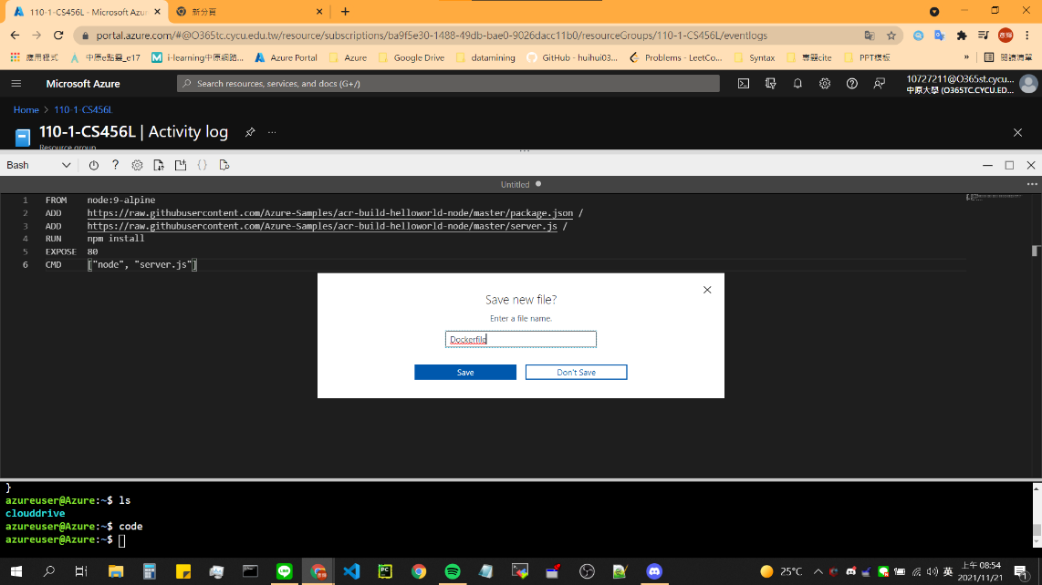

1. Build Image then push to Azure Container Registry && Verify

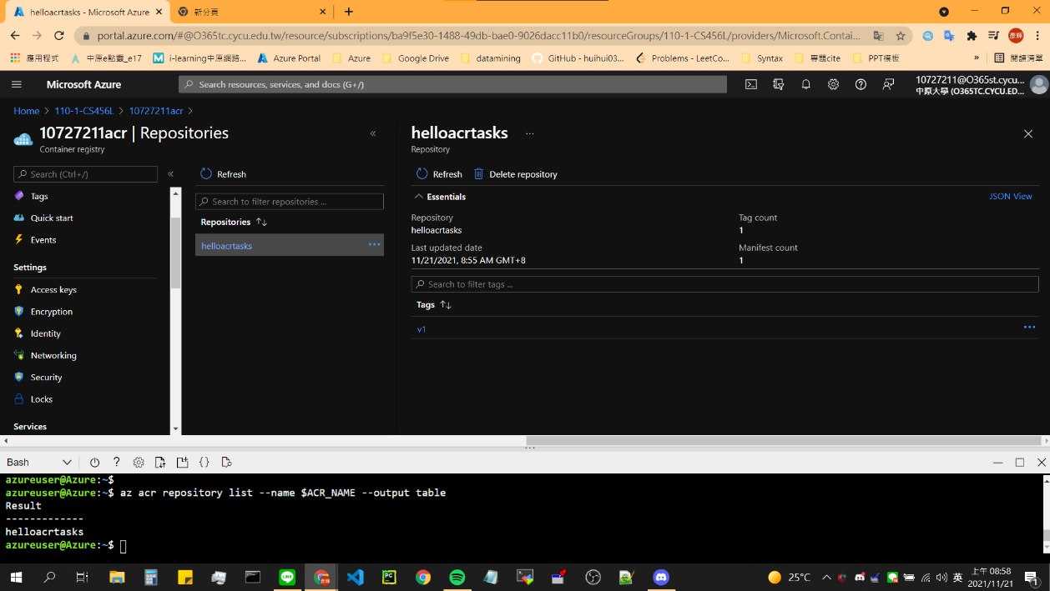

1. Enable the registry admin account (using Azure Cloud Shell)

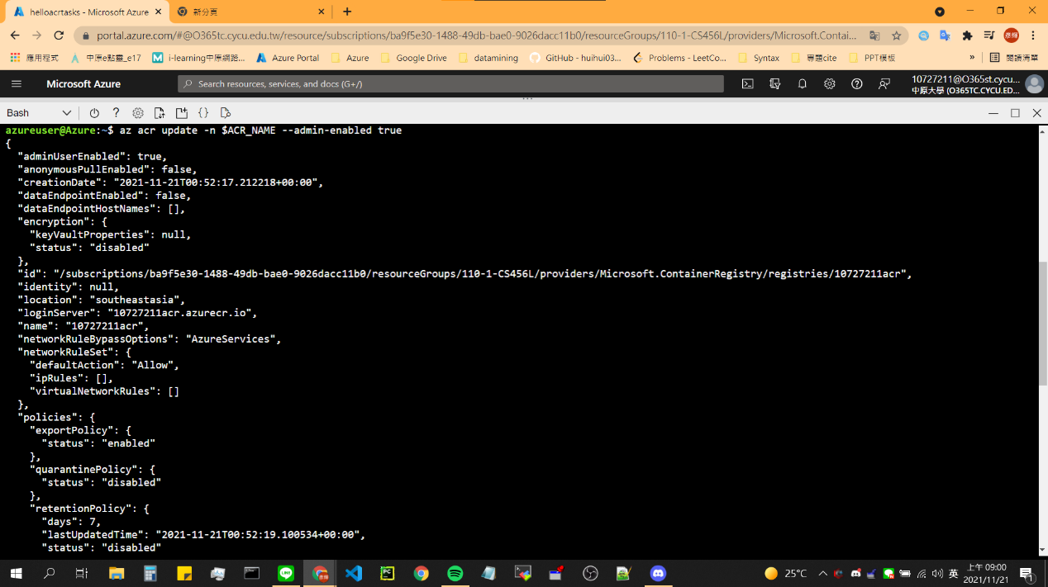

1. show credential (using Azure Cloud Shell)

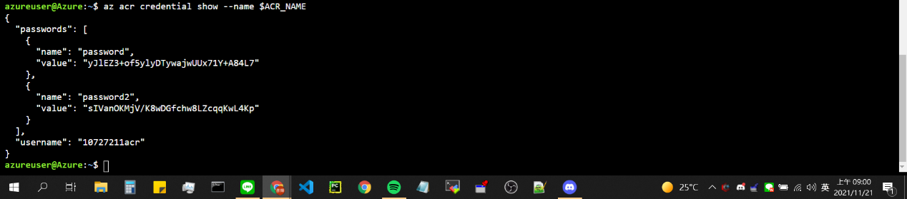

1. Deploy a container

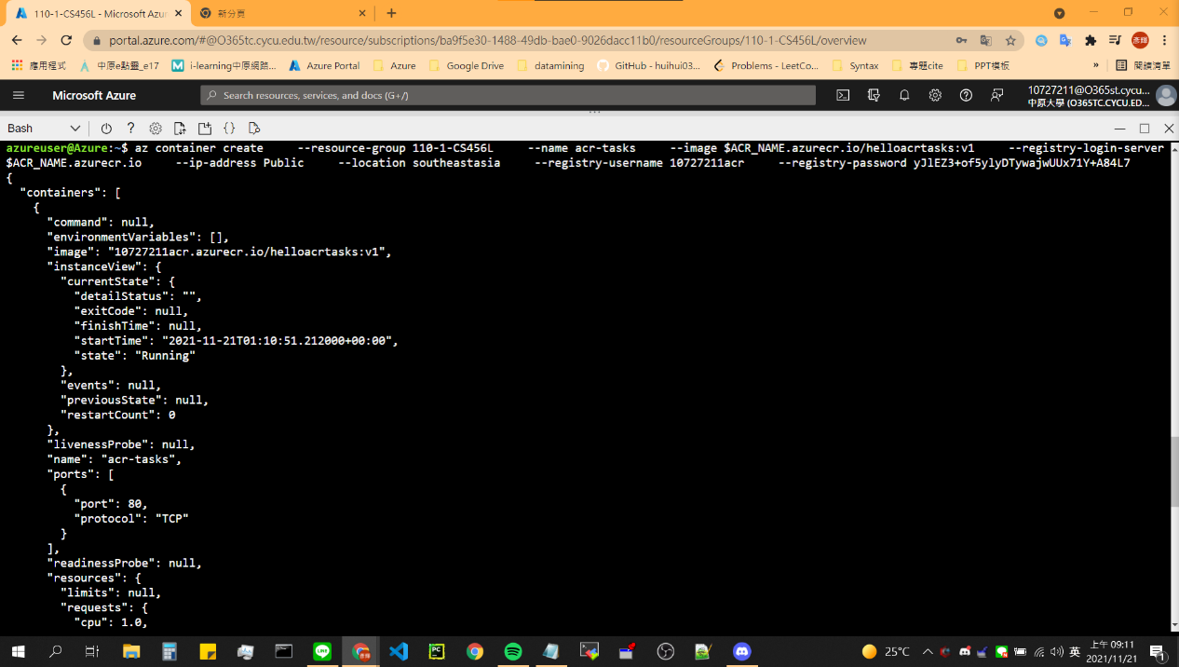

1. Get IP Address

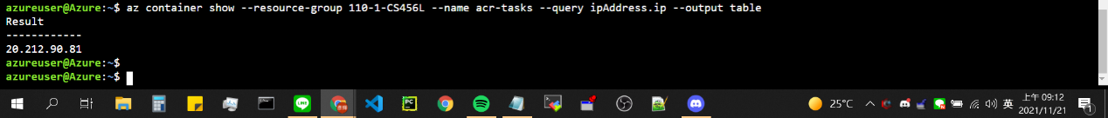

1. Result

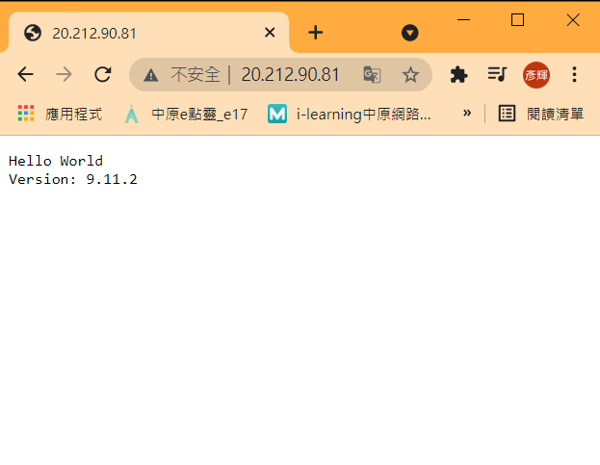

1. Create a replicated region for an Azure Container Registry &&

List Azure Container Registry( using Azure Cloud Shell)

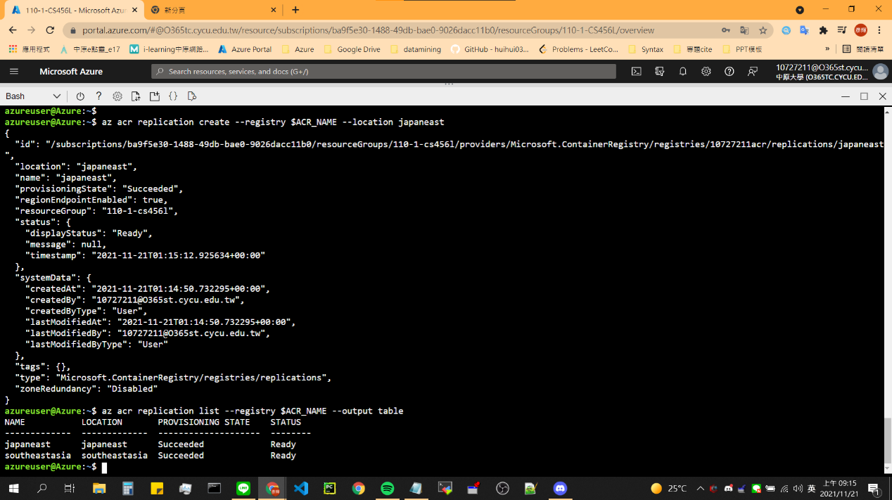

1. List Azure Container Registry (using Web)

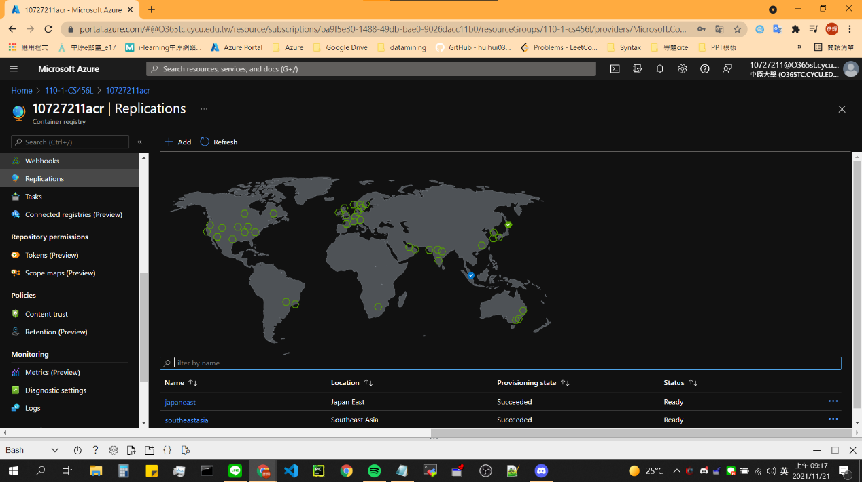

## Model 4:Run Docker containers with Azure Container Instances

1. Create a container

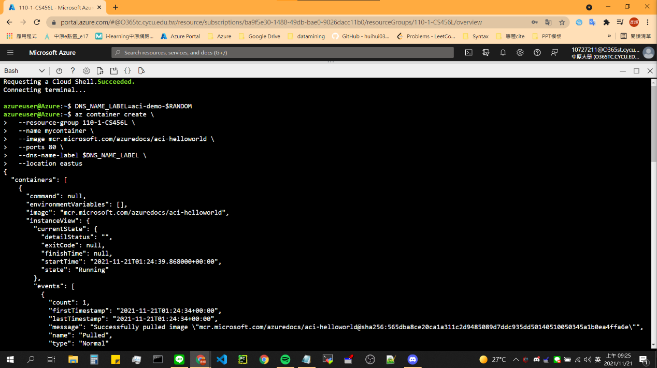

1. Check Container

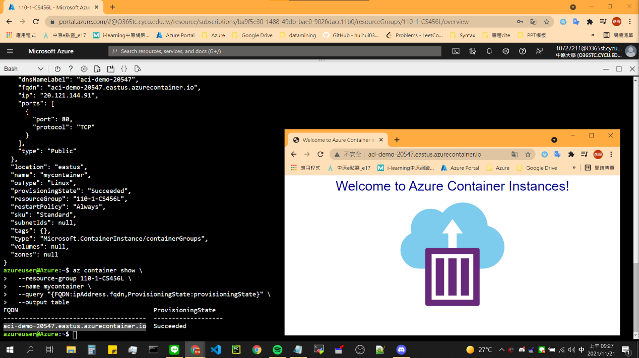

1. Create Container

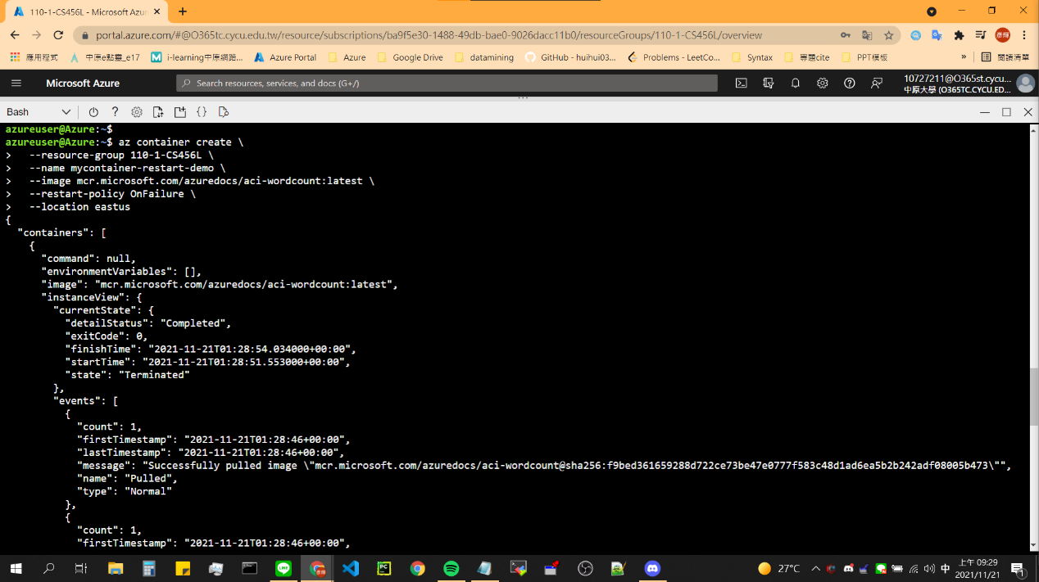

1. Check Status util ‘Terminated’ && View log

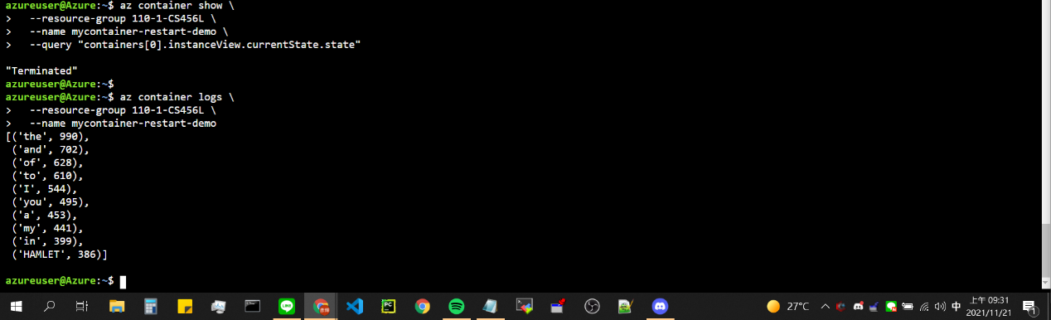

1. Create CosmosDB + save Bash variable && save key list

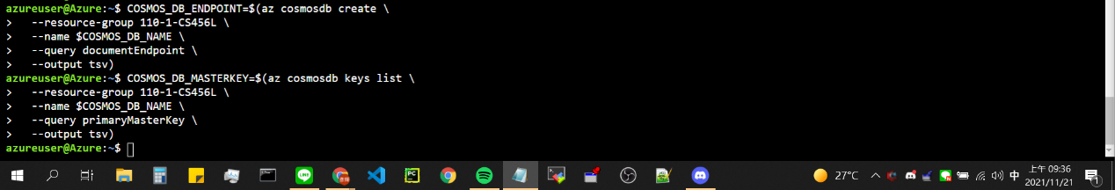

1. Deployment a container that works with CosmosDB

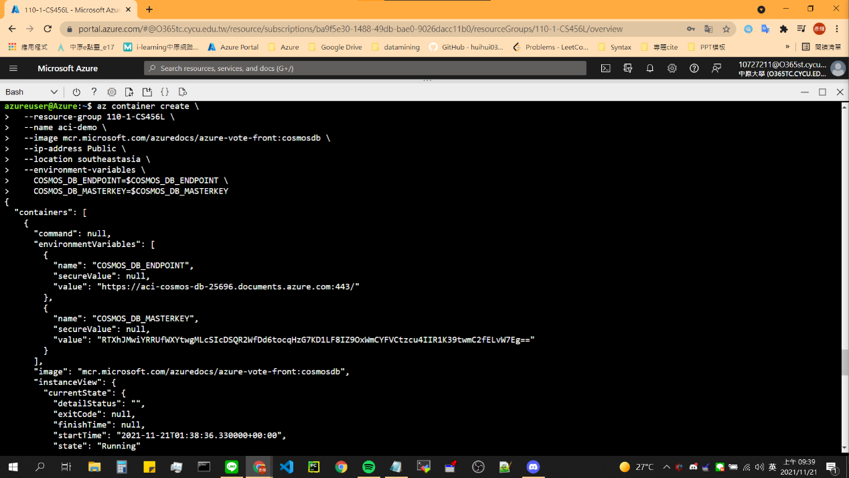

1. show IP address and Open Browser

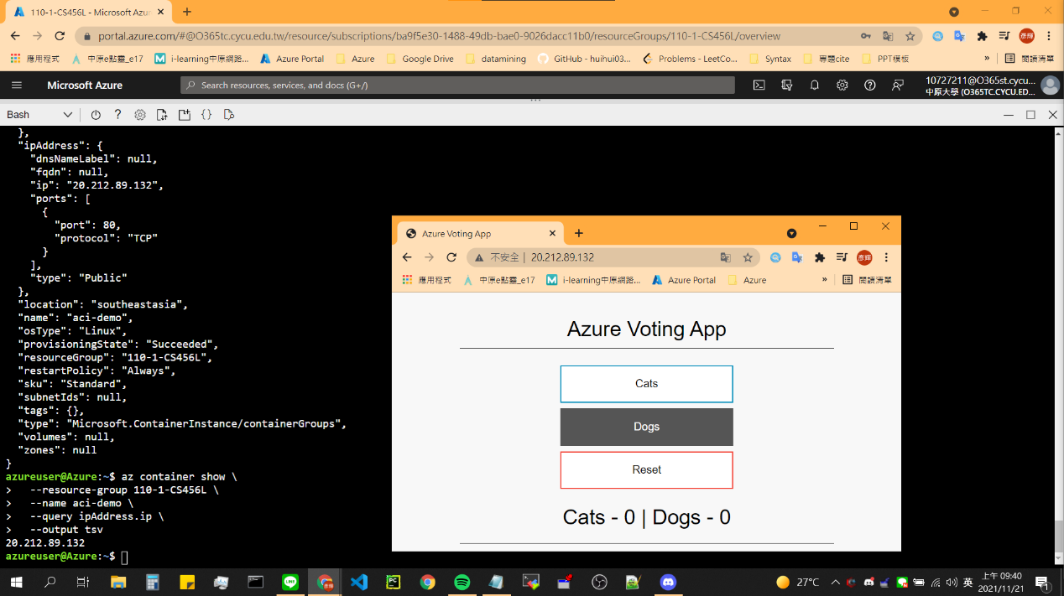

1. Show Container’s environment variables (Viewable)

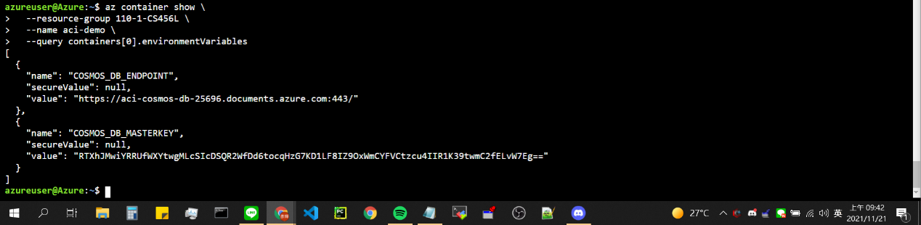

1. Create second container (using secure-environment-variables)

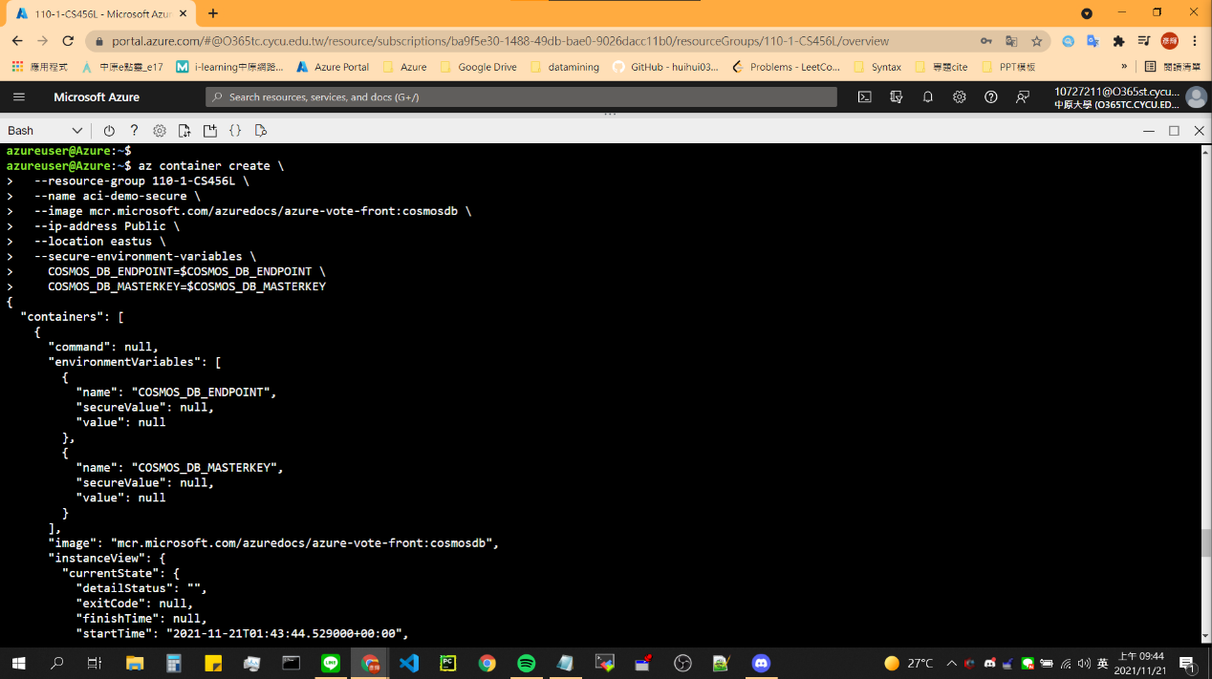

1. Show Container’s environment variables (UnViewable)

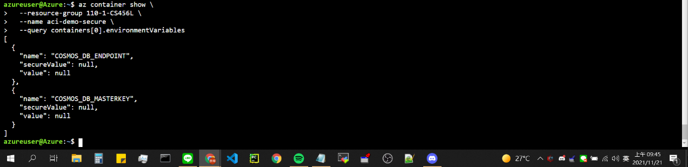

1. Create Azure storage

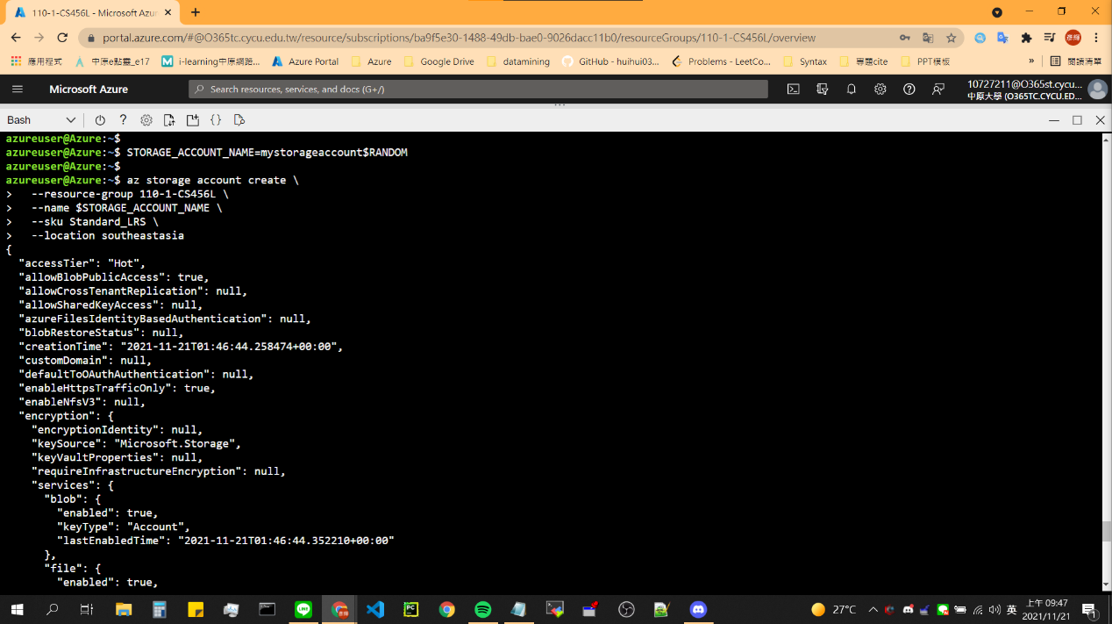

1. Get Connect String & Create File Share

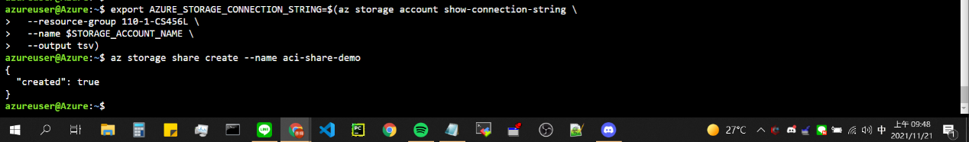

1. Get storage credentials

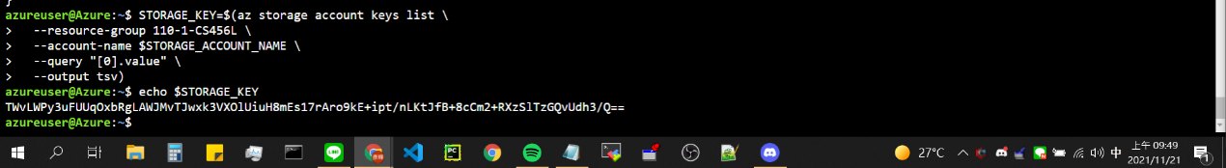

1. Deploy a container and mount the file share

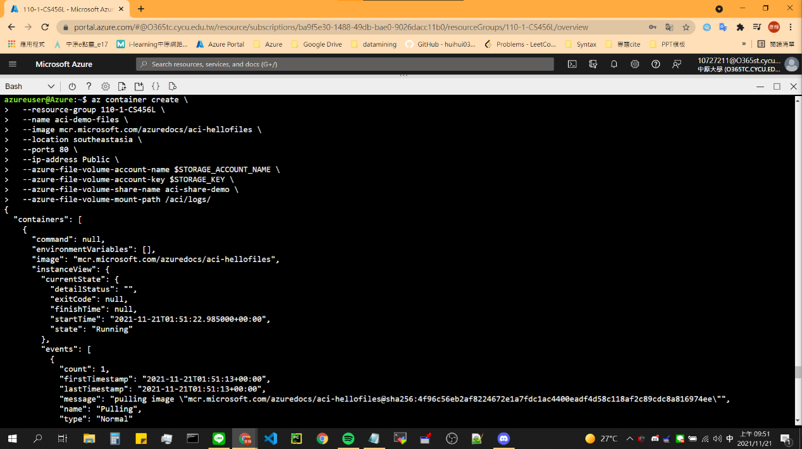

1. Get IP Address

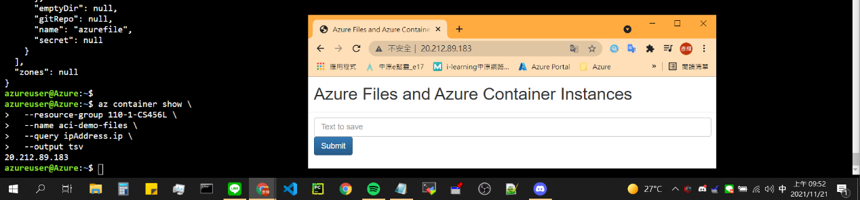

1. After Insert Text in Browser, Look & Download File in Azure Cloud Shell.

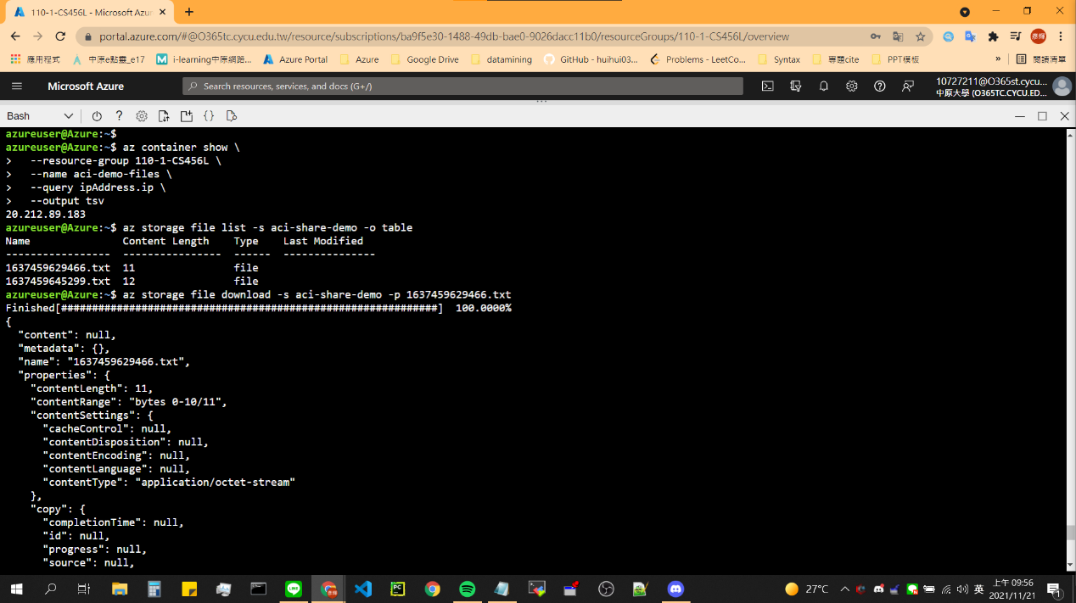

1. Show text

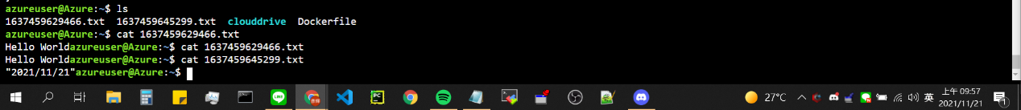

1. Get logs from your container instance

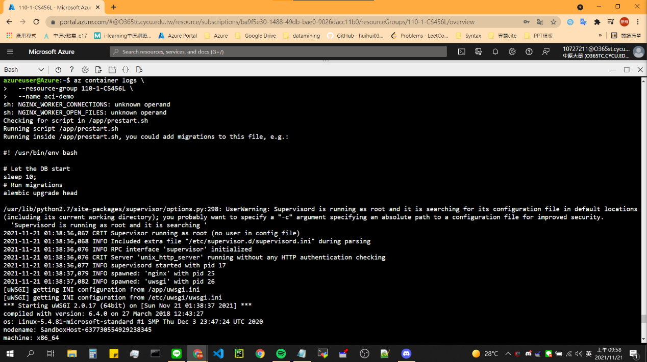

1. Get Container events

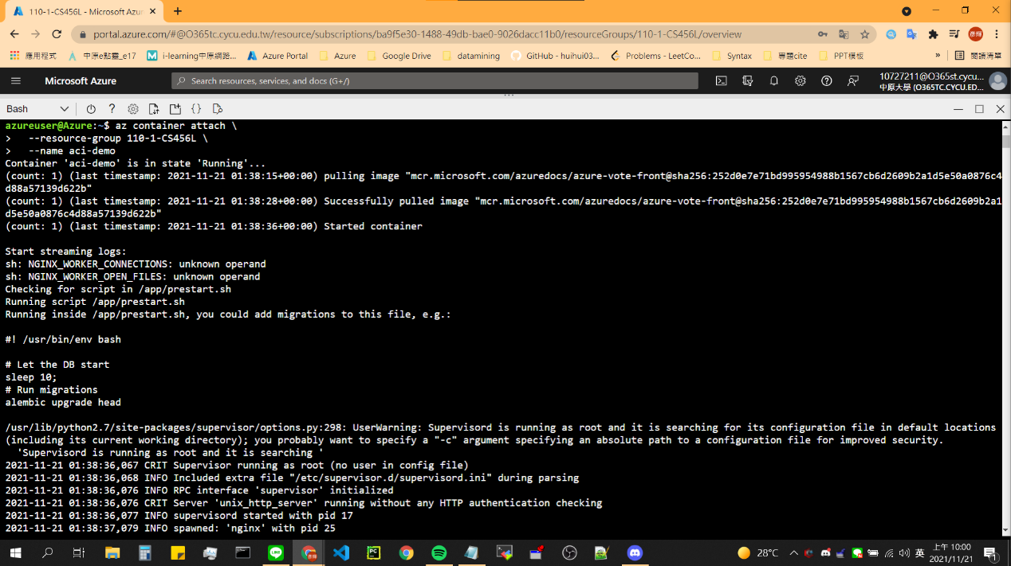

1. Execute a command in container

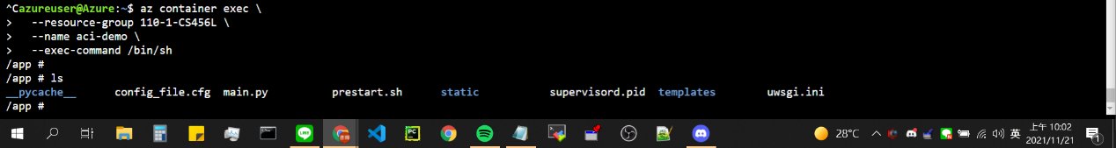

1. Monitor CPU

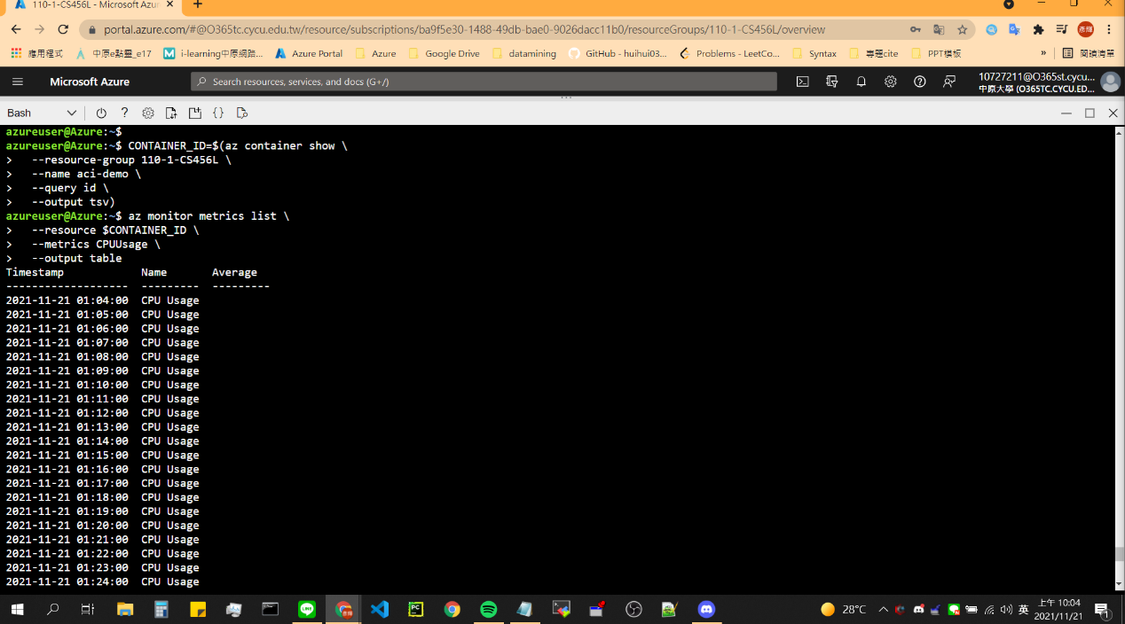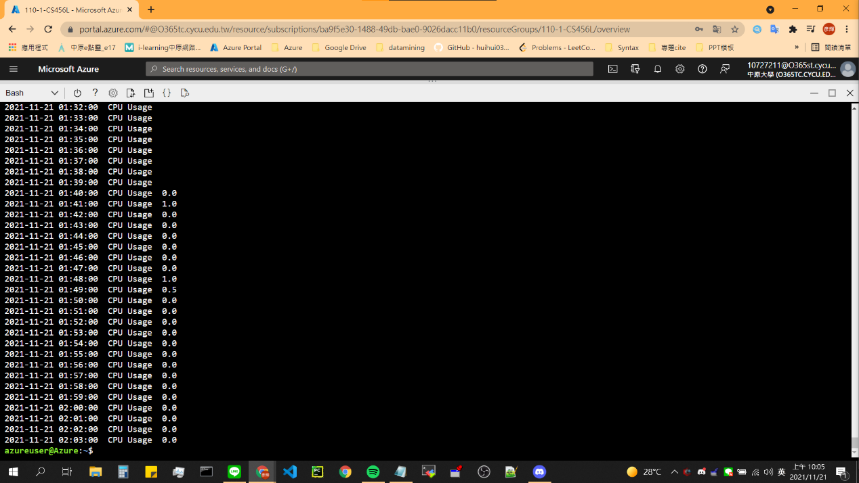

1. Monitor Memory

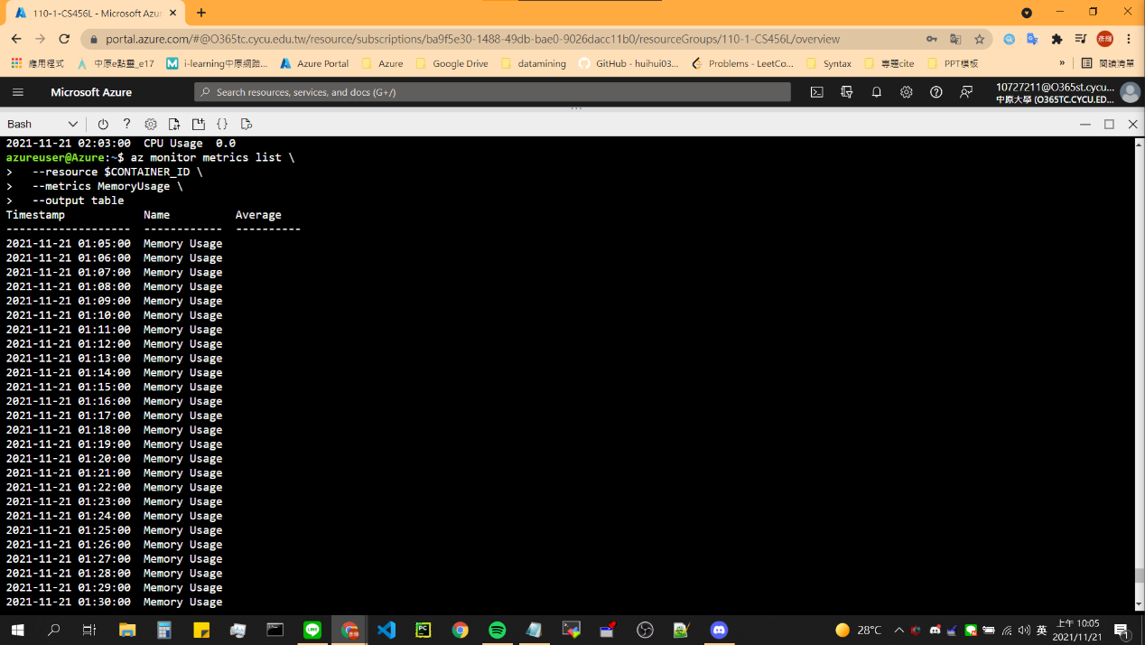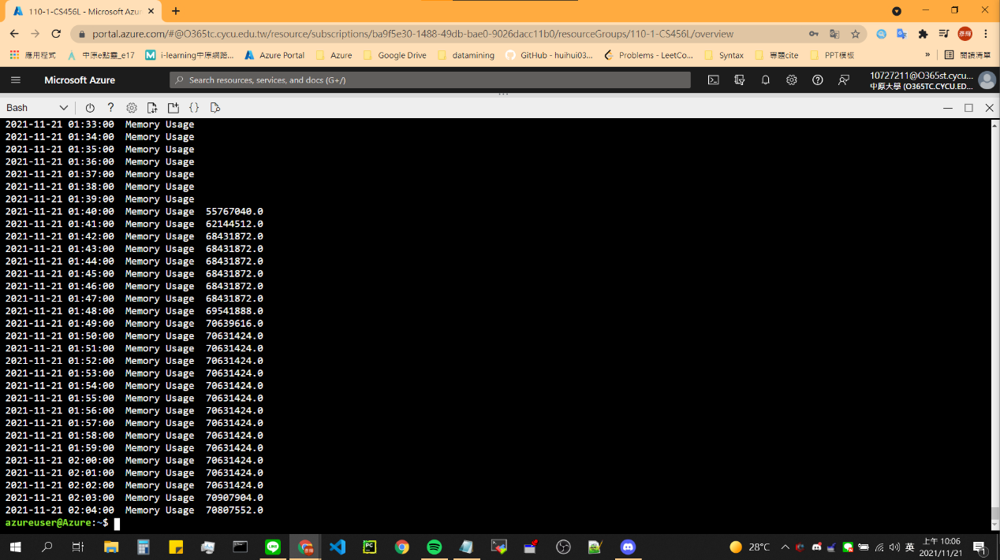

1. Container Instances Overview

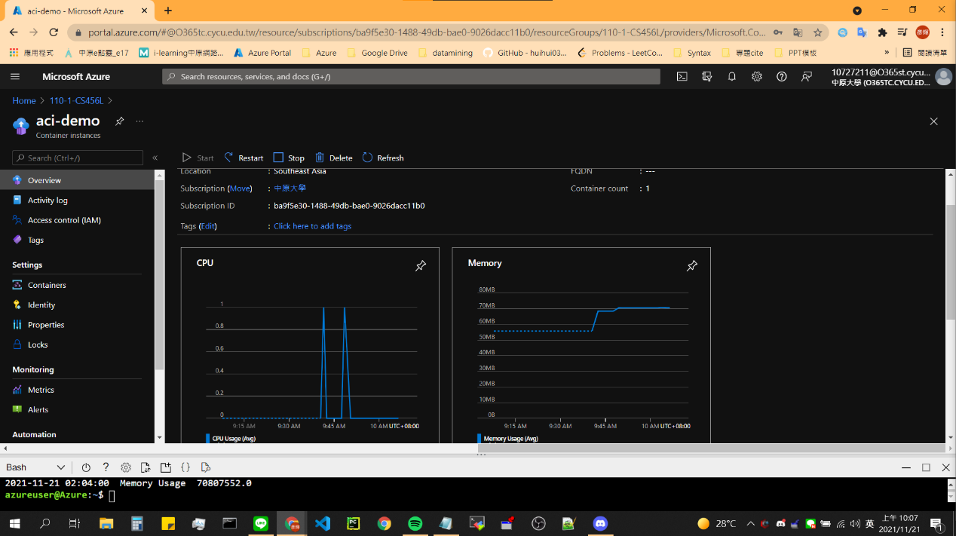

## Model 5:Deploy and run a containerized web app with Azure App Service

1. Download Code and build Images

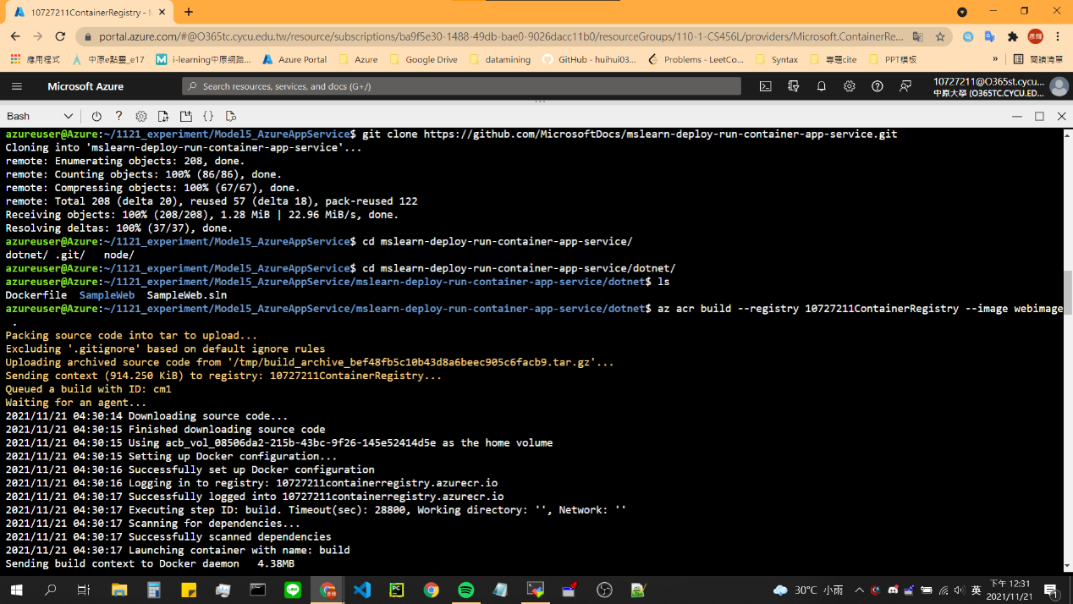

1. Check Container Registry

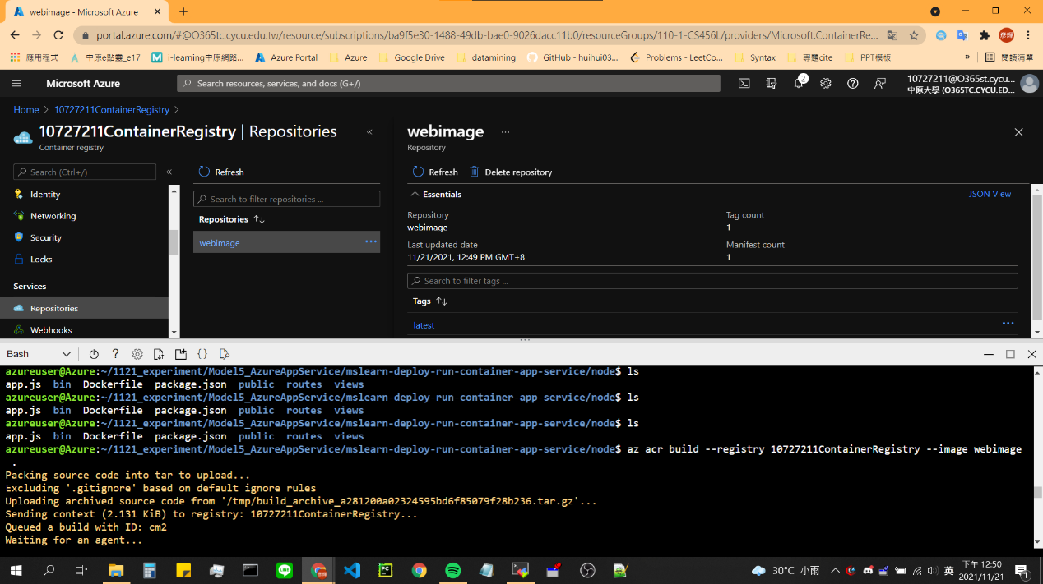

1. Create ‘Web App’ and Test

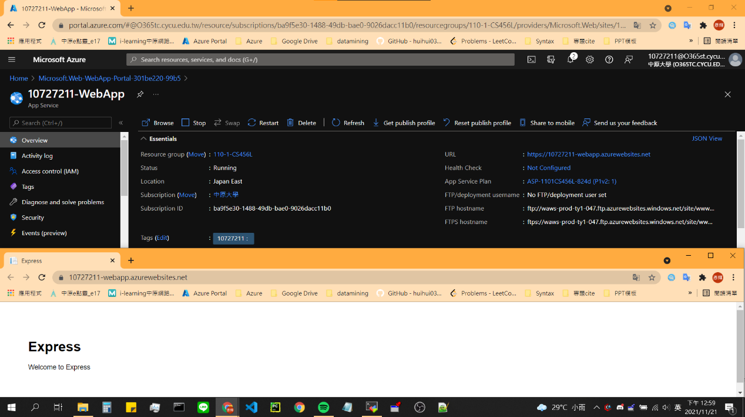

1. Configure continuous deployment and create a webhook

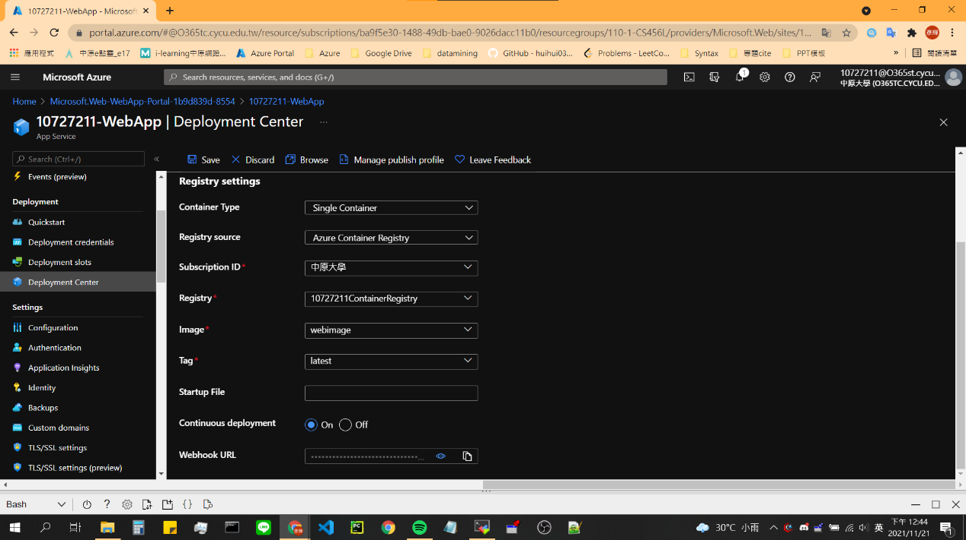

1. Update the web app

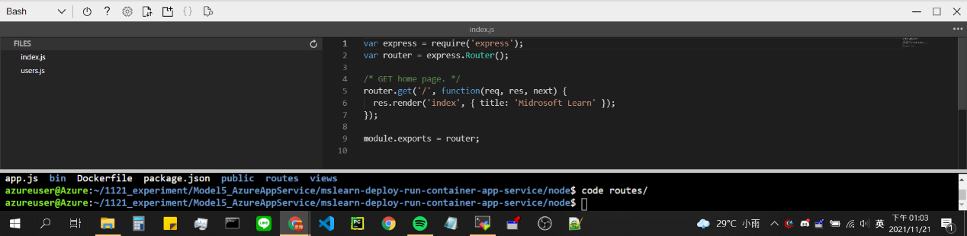

1. Check Webhook event & Test Web app

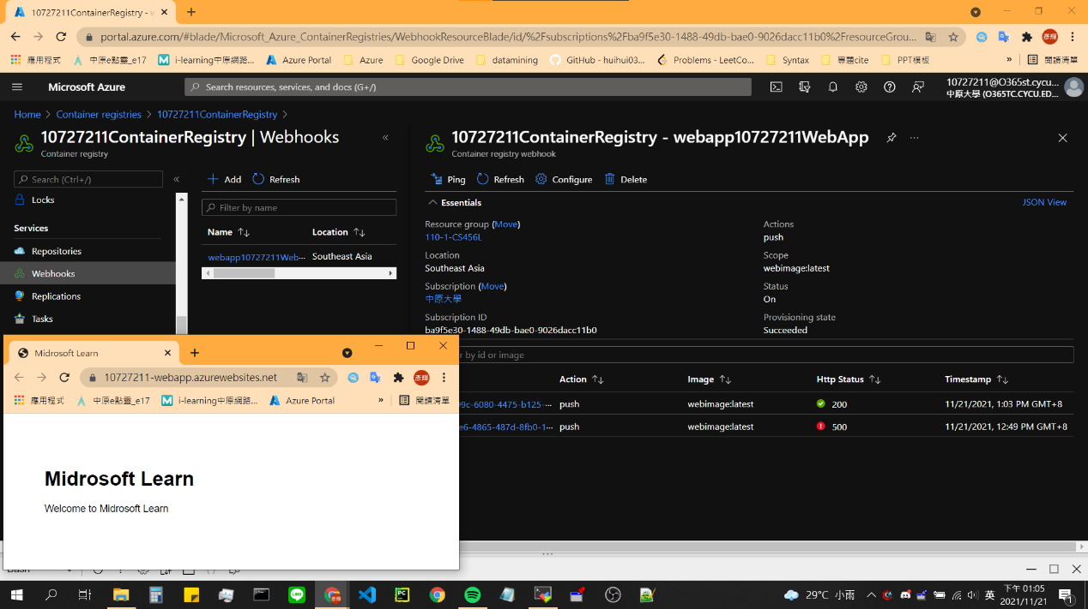

## Model 6:Introduction to Kubernetes

1. Environment (Azure VM)

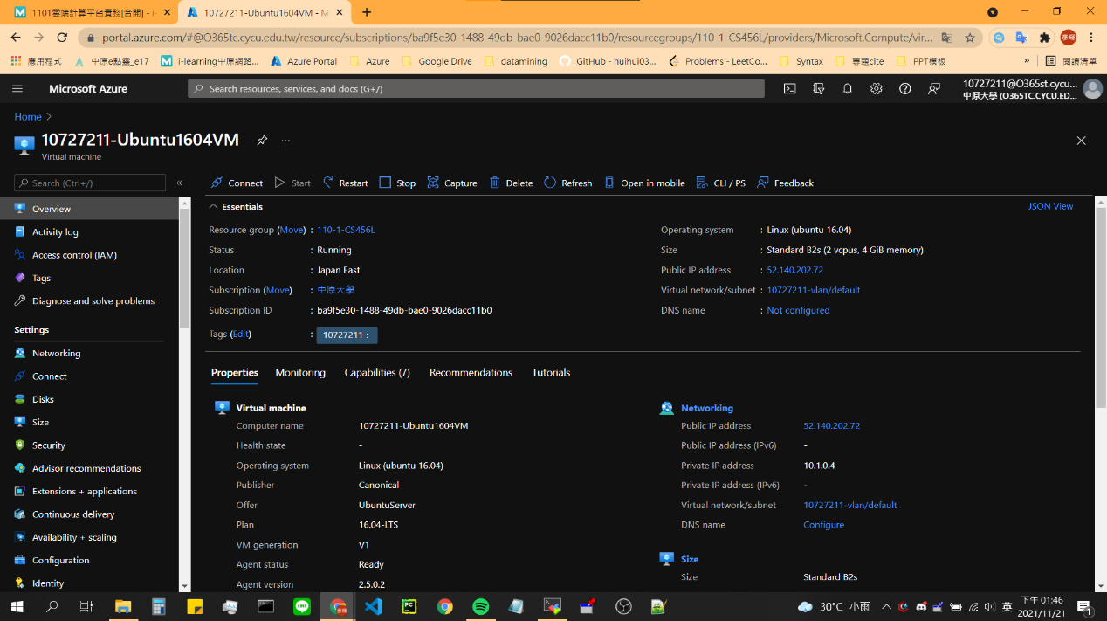

1. Install MicroK8s

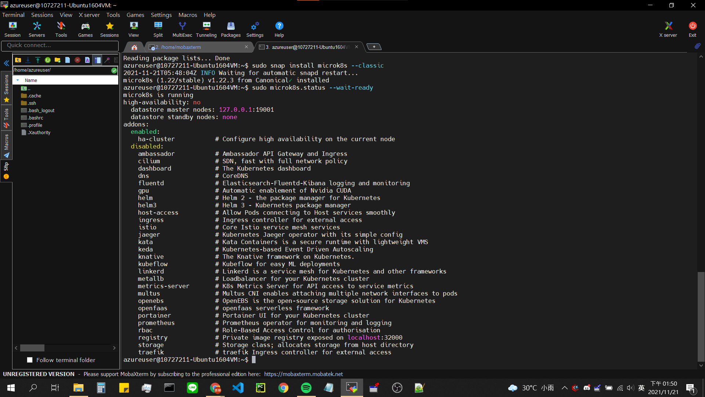

1. Prepare the cluster

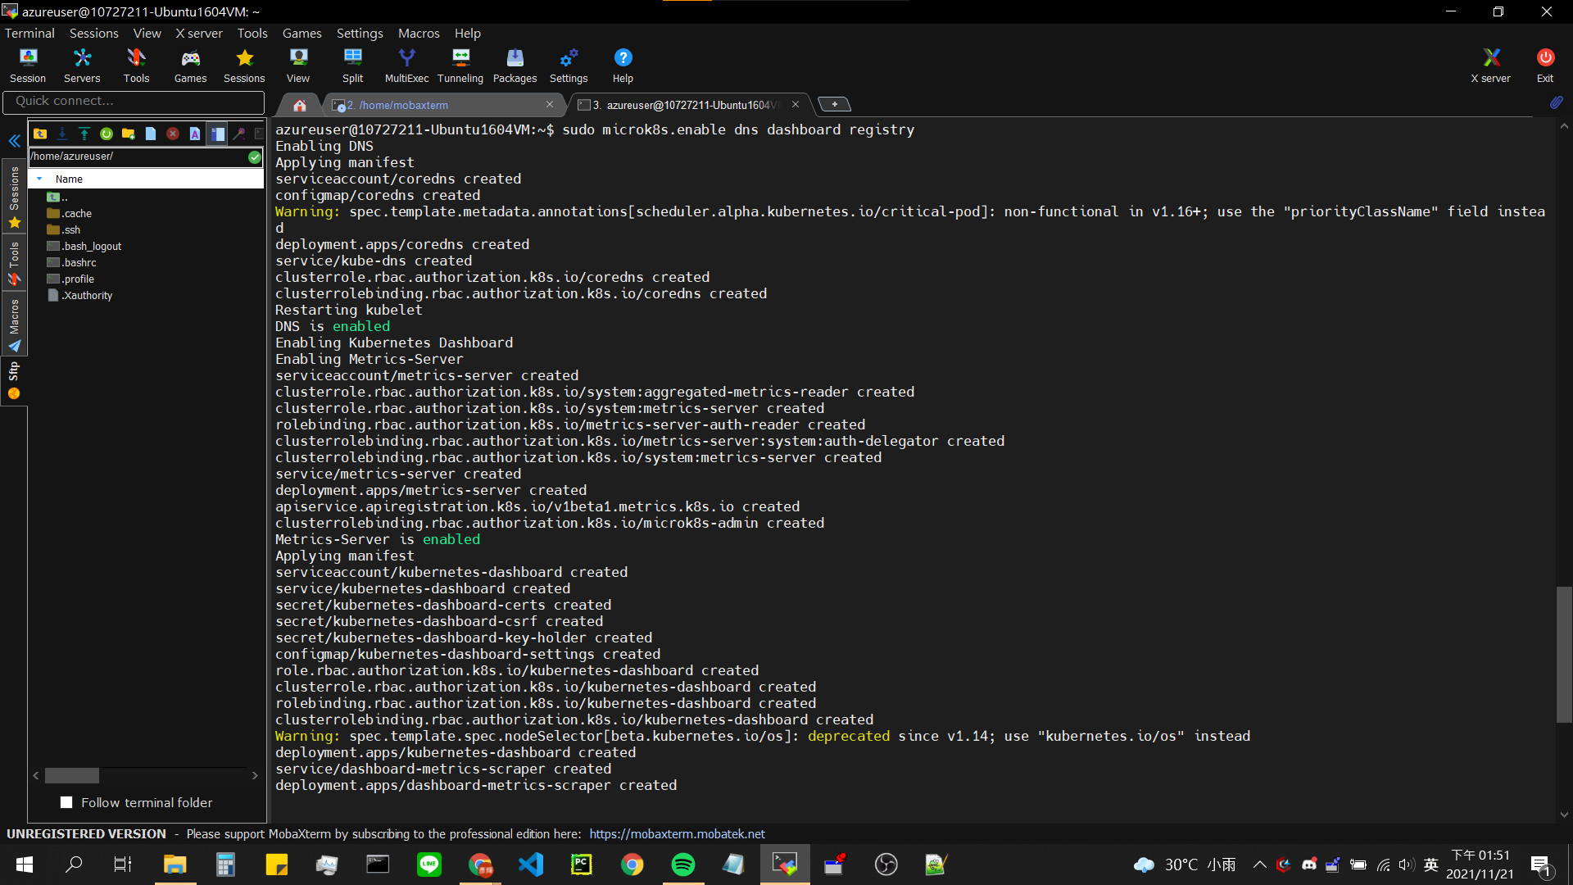

1. Explore the Kubernetes cluster && check status

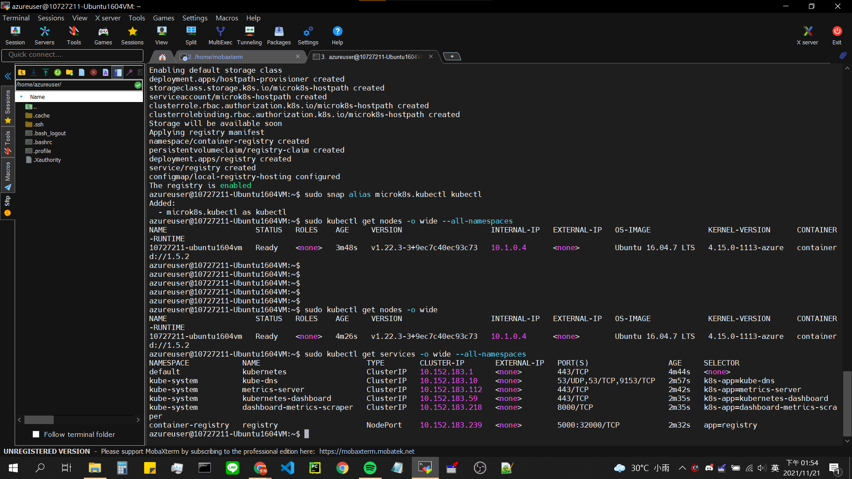

1. Install a web server on cluster

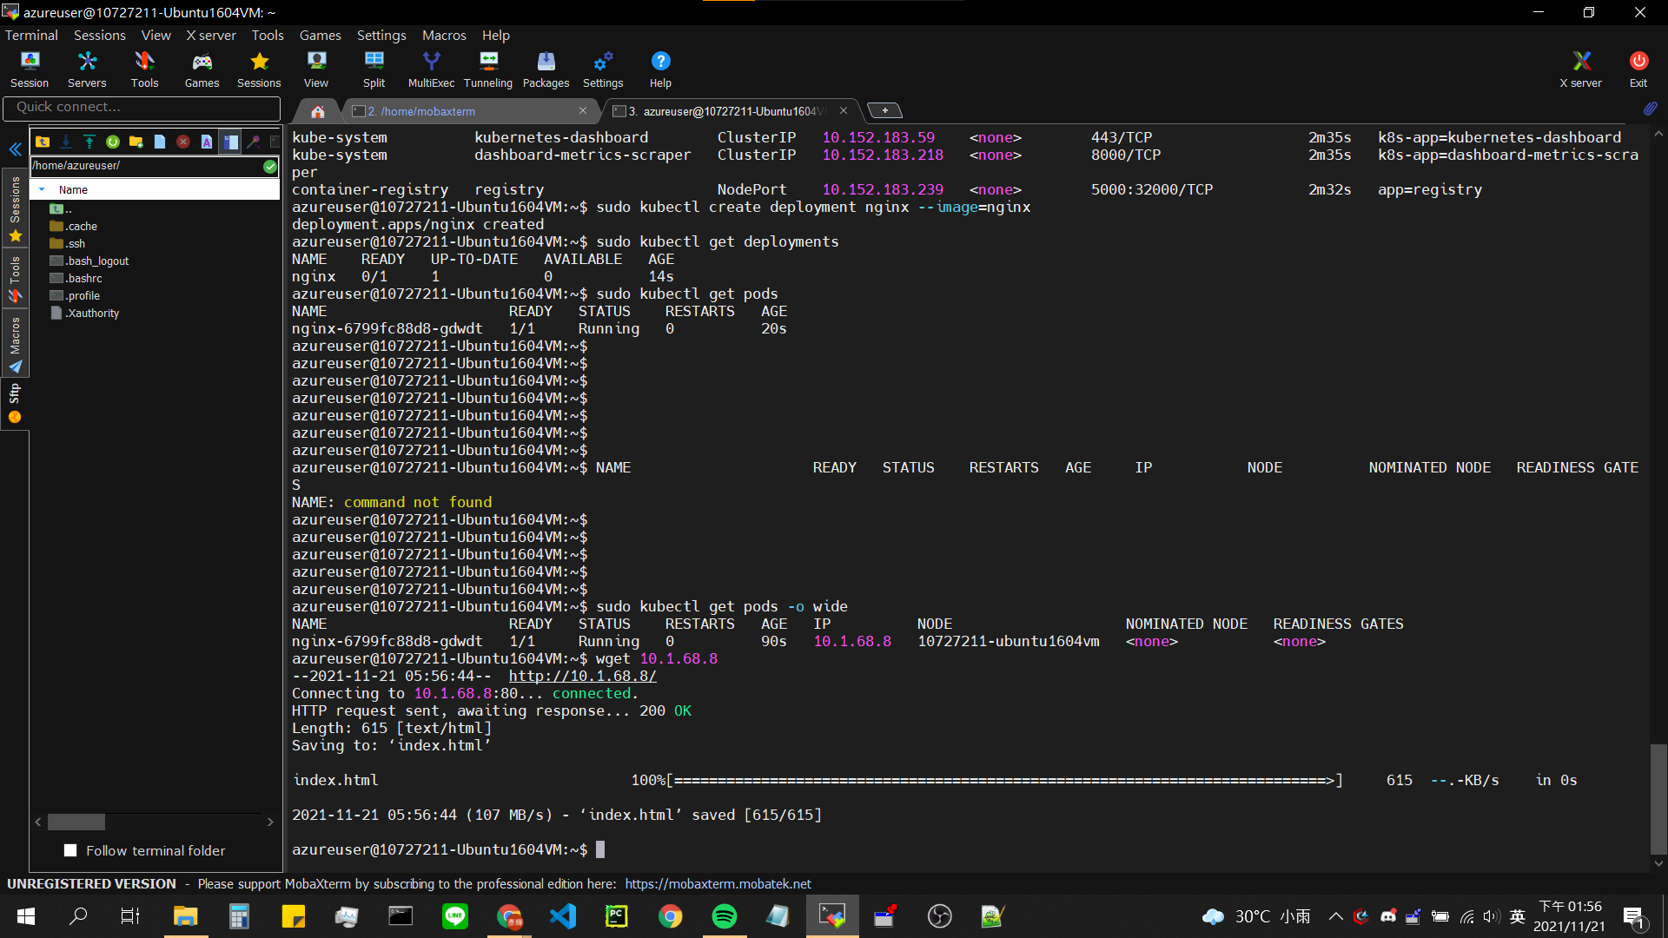

1. Test the website installation



1. Scale a web server deployment on a cluster

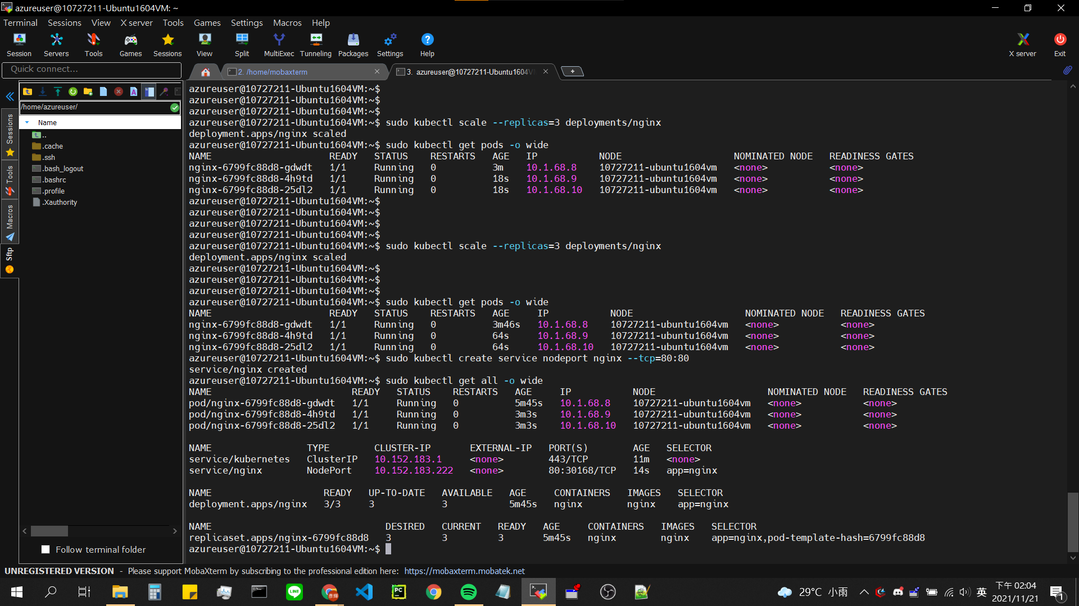

1. Setting NSG & Test

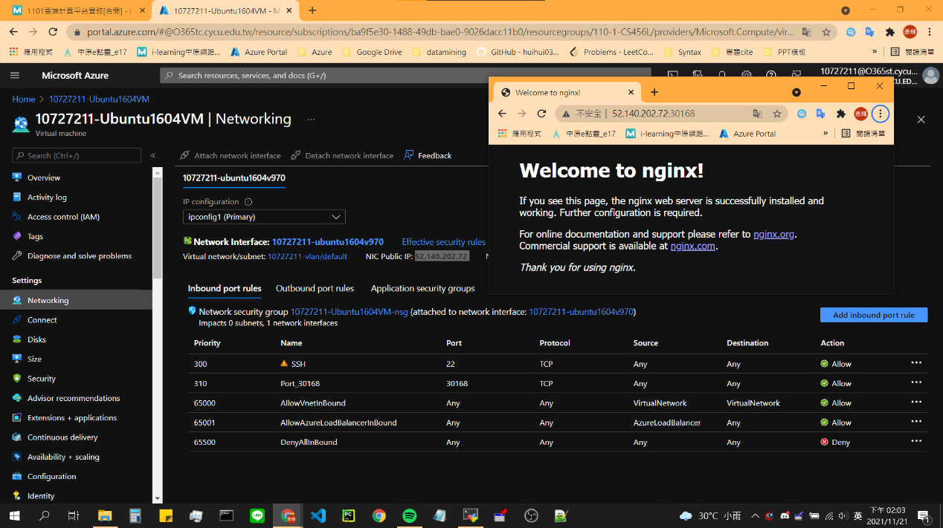

1. Uninstall MicroK8s

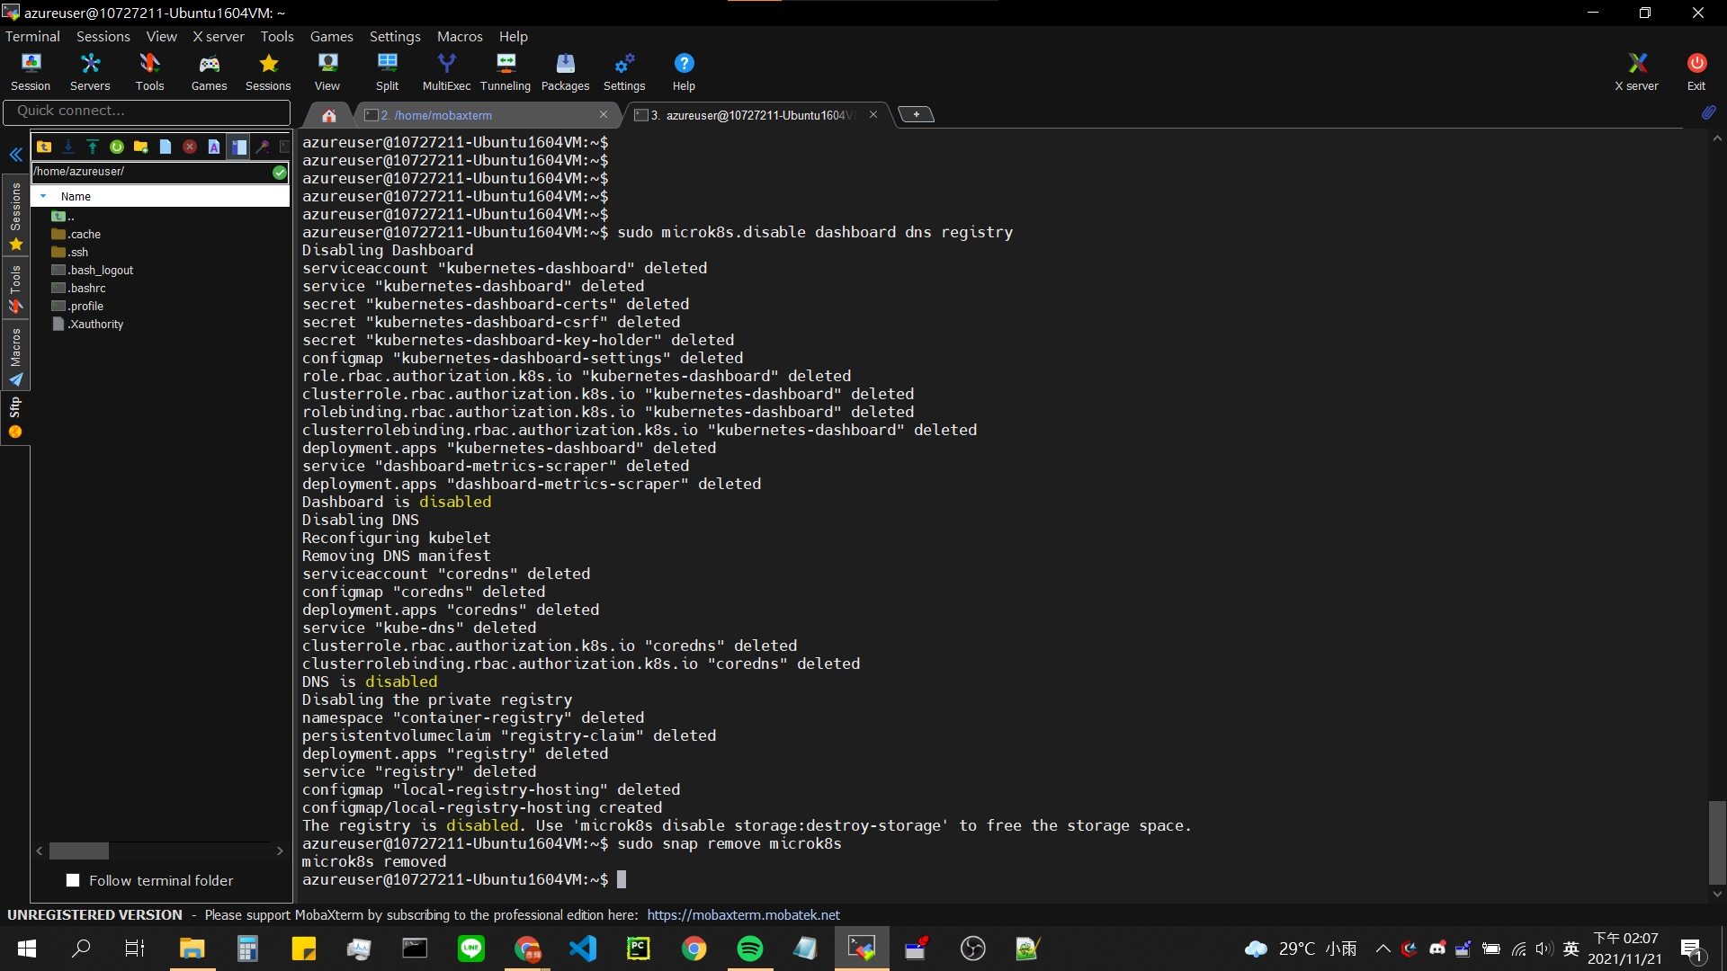

## Take screenshots of Badges and Trophies

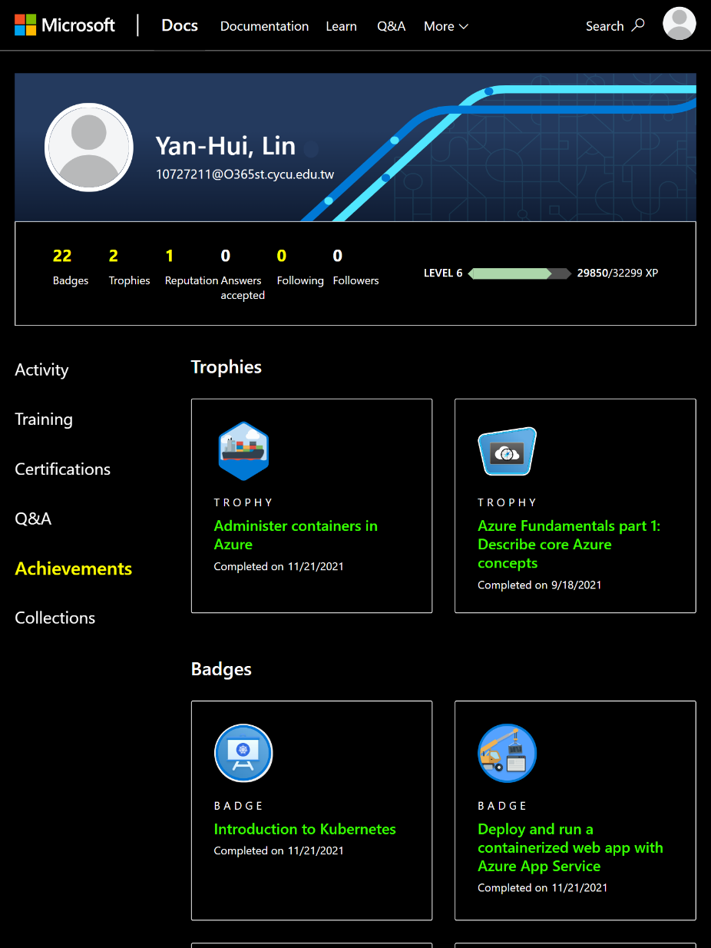

## Learned from the Learning Path

在Model1簡單介紹了容器化的技術，透過容器化的技術可以使部署更加快速，相對起VM，容器可以透過Image指定所需的環境，部署的步驟也相當簡易，使用容器化的技術可以減少資源的浪費。Model2-5開始透過實作安裝Docker，透過Sample Code簡單教導部署的流程，從中了解容器的軟體生命週期，更從中看到Azure相關的資源：Container Registry、Container Instances，在這些Model看到更多的範例教導我們如何使用這些資源，無論是GUI介面或是CLI介面，讓使用者學習更多不僅僅是容器的知識，更藉由Azure相關資源提供更多優秀的服務。最後提到了AKS，從中學習到簡單Cluster的部署方式，但可惜此Model中使用MicroK8s進行實作，真正AKS的實作未包含在此學習路徑上。

# 3. Problems

整體實作上無太大困難，僅需要時間適應Azure Portal的介面，練習多了就能適應Azure的部署機制。在NSG在設定上曾經有出現障礙，下圖為其中一個例子，在網頁需要Port-forward的條件下， Protocol的區塊需要額外指定’TCP’，若選擇預設的’Any’則無法成功Port-Forward。



# FeedBack

儘管這是一個相當基礎的Model，但仍希望Microsoft官方可以針對此Learning Path提供SandBox，否則針對想學習容器技術的初學者而言可能是個不友善的環境，其餘部分包含解說精細、範例程式都能正常work，是個相當適合新手的教學。